Activity_Storage Management System 10/16/26

II. Equipment and software requirements

Requirement | Specification
Host computer | Windows, macOS, or Linux
Virtualization software | Oracle VM VirtualBox
Guest operating system | Ubuntu Desktop Linux
RAM allocated to VM | 4 GB recommended
Virtual disk 1 | Existing Ubuntu system disk
Virtual disk 2 | Additional 5 GB virtual disk for laboratory exercises
Disk utility | Ubuntu Disks or fdisk
Terminal utilities | lsblk, df, du, mount, umount, mkfs, chmod

Important safety rule: The additional 5 GB disk is for the hands-on partitioning and formatting exercises. Do not format the Ubuntu system disk or any disk containing personal data. Commands that use mkfs, fdisk, or parted can destroy data if the wrong device is selected.

Pre-laboratory preparation: Set up VirtualBox Part A. Prepare the Ubuntu virtual machine
If Ubuntu is already installed in VirtualBox, proceed to Part B.

- Open Oracle VM VirtualBox.
- Select your Ubuntu virtual machine.
- Click Settings → System → Motherboard and confirm that sufficient memory is allocated. Use around 4 GB if your computer has enough RAM.
- Under Settings → Storage, verify that the Ubuntu virtual hard disk is attached.
- Start the virtual machine and log in to Ubuntu.
- Open Terminal by pressing Ctrl + Alt + T. To verify that Ubuntu is running, enter:
uname -a

Then inspect the system's storage devices:

lsblk

Expected observation: You should see at least one disk, commonly named /dev/sda, with partitions for the Ubuntu installation. The exact device names and partition layout can vary. 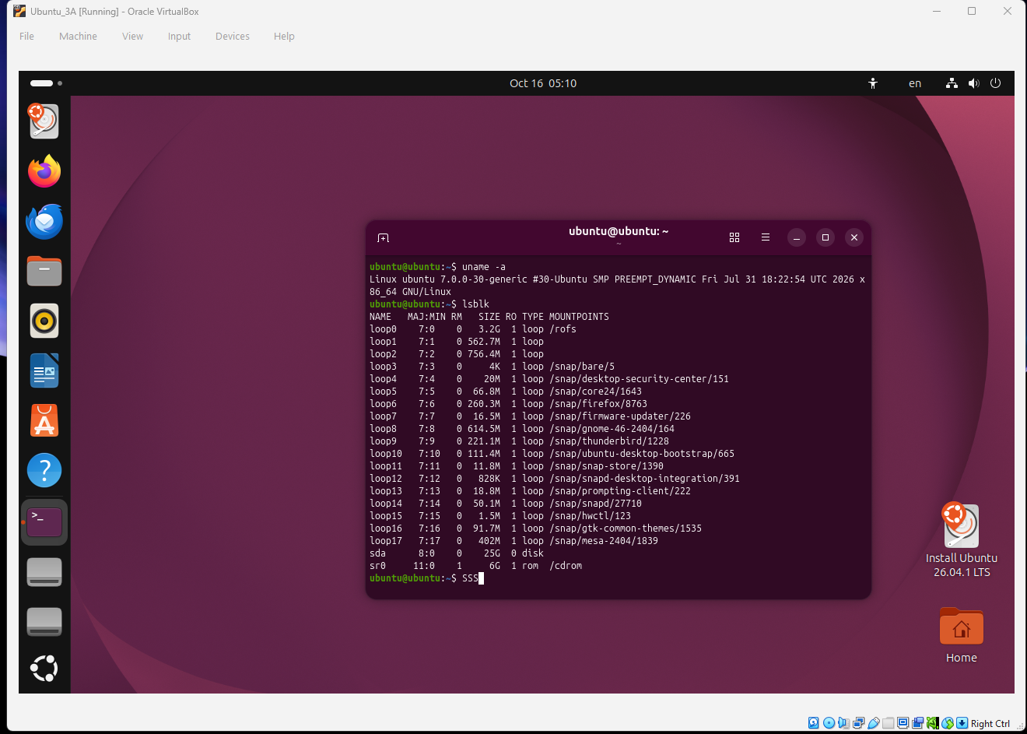

Part B. Add a separate 5 GB virtual disk

- Shut down Ubuntu completely. Do not save the virtual machine's running state.
- In VirtualBox Manager, select the Ubuntu VM.
- Open Settings → Storage.
- Select the virtual storage controller, usually SATA.
- Click the icon for adding a hard disk and choose Create.
- Select the VDI disk format.

- Choose Dynamically allocated.
- Name the disk StorageLab.vdi.
- Set its maximum size to 5 GB.
- Finish the wizard and verify that the new disk appears under the controller.
- Click OK, then start Ubuntu.
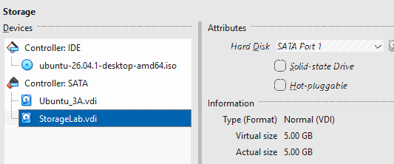

Safety checkpoint

A dynamically allocated 5 GB disk can grow as data is written to it, up to its configured capacity. It does not necessarily occupy the full 5 GB on the host immediately. The virtual disk is separate from your Ubuntu system disk, but always verify the target device before making changes.

Laboratory exercises

Exercise 1. Inspect the storage devices

Objective: Identify the virtual disks, partitions, file systems, and mount points recognized by Ubuntu. Instructions
  - Open Terminal.
  - Run the following commands one at a time:

Lsblk
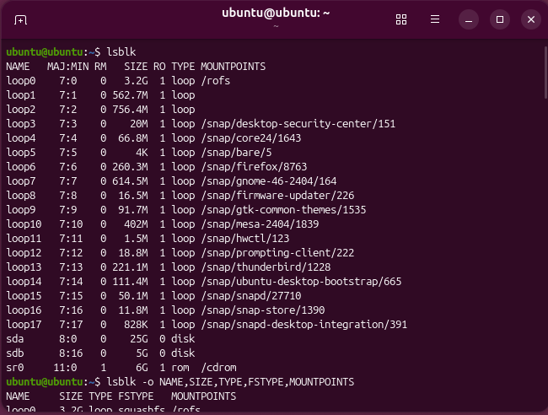

lsblk -o NAME,SIZE,TYPE,FSTYPE,MOUNTPOINTS
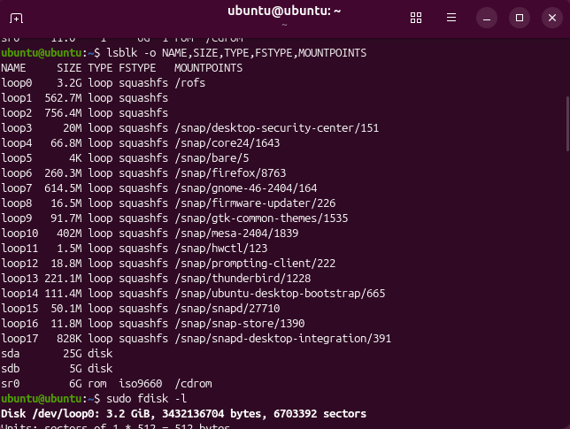
sudo fdisk -l
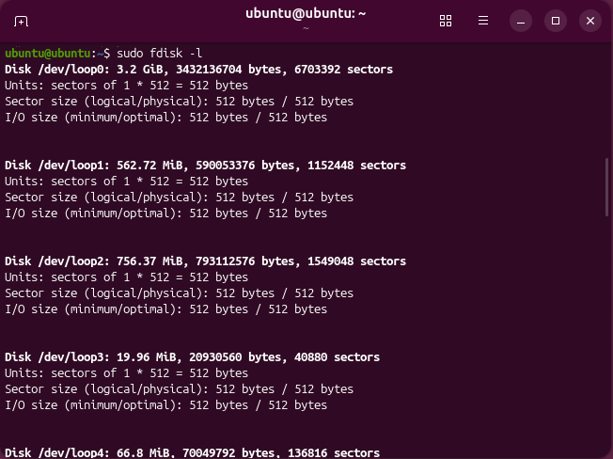

df -h
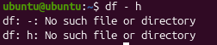

  - Observe the output of each command.
  - Identify the disk containing Ubuntu and the newly added 5 GB disk.
  - Record the device names, sizes, partition information, file systems, and mount points in your laboratory report.

Command guide

Command | Purpose
lsblk | Lists block storage devices and partitions
lsblk -o ... | Displays selected storage information
sudo fdisk -l | Lists disk partition tables
df -h | Displays file-system capacity and available space in readable units

Expected observation: The additional disk should appear as a separate device, usually without partitions or a file system. The exact name may be /dev/sdb, /dev/sdc, or another device name.

Guide question: Why is it important to identify the correct disk before creating partitions or formatting it?
- Partitioning and formatting overwrite the partition table and file-system metadata, which makes the existing data effectively unrecoverable. Device names like /dev/sdb are not guaranteed, because they depend on detection order. If you pick the wrong one, such as the Ubuntu system disk, you can destroy the operating system or personal data. Checking size, partitions, and file system with lsblk and fdisk -l first confirms you are targeting the empty 5 GB lab disk.

Exercise 2. Partition the additional virtual disk Objective: Create a partition on the 5 GB laboratory disk. Do not skip disk verification
Never assume that the new disk is /dev/sdb. Check the output of lsblk and sudo fdisk -l first. Do not use the Ubuntu system disk or any disk containing valuable data.

Instructions

- From Exercise 1, identify the new 5 GB disk.

- In the commands below, replace /dev/sdX with the verified device name of the new disk. For example, if the additional disk is /dev/sdb, use /dev/sdb.

sudo fdisk /dev/sdX

- At the interactive fdisk prompt, enter the following commands one at a time:

g n 1
[Press Enter for the default first sector] [Press Enter for the default last sector] p
W
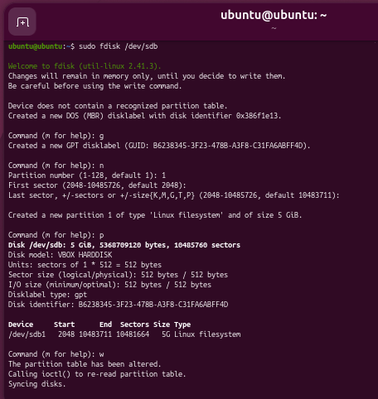

- Follow the prompts. The commands create a GPT partition table and one partition using the available disk space. The w command writes the changes.
- Verify the result:

Lsblk
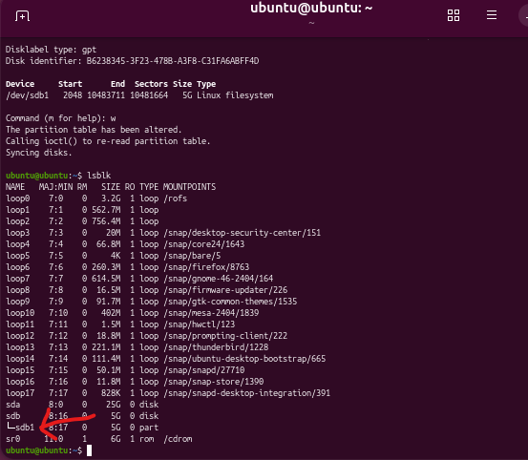

sudo fdisk -l /dev/sdX
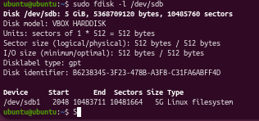

Expected observation: The disk should now contain one partition, commonly named /dev/sdb1 if the disk is /dev/sdb.

Important: If fdisk reports that the disk contains existing partitions or data you did not expect, stop and ask your instructor before proceeding.

Guide questions

  - What is the difference between a physical or virtual disk and a partition?
- A disk is the whole storage device, either physical hardware or a virtual disk file like StorageLab.vdi. A partition is a logical section of that disk, such as /dev/sdb1, that the OS treats as a separate storage unit.
  - Why might a storage device be divided into multiple partitions?
- To separate the OS from user data, so reinstalling the OS does not erase the data.
- To run multiple operating systems on one disk (dual boot).
- To use different file systems on different sections.
- To contain damage, since a full or corrupted partition does not affect the others.
- To set aside areas for swap, boot files, or backups.
  - What information does a partition table store?
- It records where each partition starts and ends (first and last sectors), the partition sizes, the partition types, and any flags (such as bootable). With GPT, it also stores partition GUIDs and names, plus a backup copy of the table at the end of the disk.

Exercise 3. Format the partition with a file system

Objective: Prepare the new partition to store files.

Linux requires a file system, such as ext4, before a normal partition can be used for file storage. Instructions
- Verify the partition name using:

lsblk -f
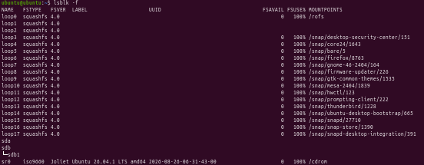

- Confirm that the partition belongs to the additional 5 GB disk.
- Format that partition as ext4. Replace /dev/sdX1 with the verified partition name.

sudo mkfs.ext4 /dev/sdX1
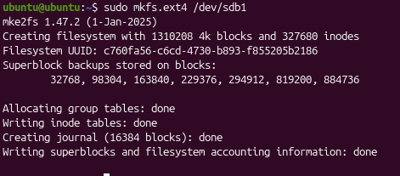
- Wait until the command completes.
- Verify the file system: lsblk -f
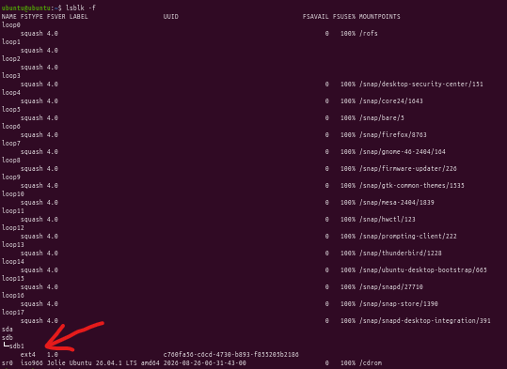
Expected observation: The new partition should show ext4 as its file-system type.
Guide questions

- What is the purpose of formatting a partition?
- Formatting creates a file system (such as ext4) on the partition. The file system provides the structures the OS needs to organize, name, store, locate, and protect files, such as inodes, directories, and free-space tracking. Without one, a partition cannot be used for normal file storage.
- Why can formatting the wrong partition result in data loss?
- mkfs writes new file-system structures over the old ones, so the previous directory and allocation information is lost. The files can no longer be located, and the data may be overwritten.
- What is the difference between partitioning and formatting?
- Partitioning divides the disk into regions and records them in the partition table. Formatting prepares one of those regions with a file system so it can hold files. Partitioning comes first and defines the space; formatting makes it usable.

Exercise 4. Mount and use the new storage device

Objective: Make the formatted partition accessible through Ubuntu's directory structure. Instructions
- Create a mount-point directory:

sudo mkdir -p /mnt/storagelab
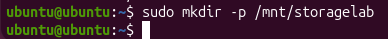
- Mount the partition. Replace /dev/sdX1 with your verified partition name. sudo mount /dev/sdX1 /mnt/storagelab
- Check that the partition is mounted:

findmnt /mnt/storagelab df -h /mnt/storagelab
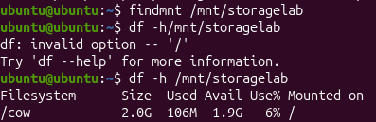

- Create a directory for your laboratory files:

sudo mkdir -p /mnt/storagelab/CE_Lab

- Give your current Ubuntu user ownership of the laboratory directory:

sudo chown "$USER":"$(id -gn)" /mnt/storagelab/CE_Lab
- Create a test file:

echo "Operating Systems Storage Management Lab" > /mnt/storagelab/CE_Lab/lab-notes.txt
- Display its contents:

cat /mnt/storagelab/CE_Lab/lab-notes.txt

- Check the storage device again:

df -h /mnt/storagelab lsblk -f
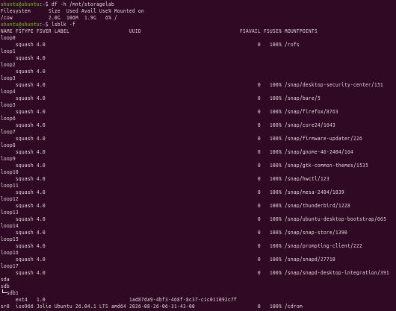
Expected observation: The test file should be readable, and df -h should show the capacity and available space of the mounted file system.

Guide questions

  - What is a mount point?
- A mount point is an existing directory, such as /mnt/storagelab, where a file system is attached to the Linux directory tree. Opening that directory shows the contents of the mounted partition.
  - Why does Linux make a storage partition accessible through a directory?
- Linux uses a single unified directory tree starting at /, rather than drive letters like Windows. Mounting lets all storage appear under one hierarchy, so programs and users access files with ordinary paths regardless of which physical device holds them. It also lets administrators move data to larger or faster disks without changing paths.
  - What is the difference between a mounted partition and an unmounted partition?
- A mounted partition is attached to a directory, so its files can be read and written through that path. An unmounted partition still exists on the disk with its data intact, but the OS is not exposing it, so its files are not accessible until it is mounted.

Exercise 5. Analyze file and directory storage usage

Objective: Measure how much storage files and directories consume.

Instructions

- Create sample files on the laboratory partition:

cd /mnt/storagelab/CE_Lab
mkdir Documents Backups Logs
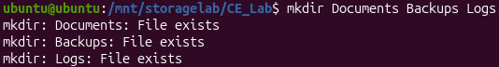
echo "Student documentation" > Documents/report.txt echo "Backup sample" > Backups/backup-notes.txt echo "System event sample" > Logs/events.txt
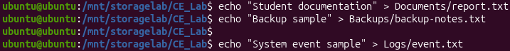

- Check the sizes of files and directories:

du -h /mnt/storagelab/CE_Lab du -sh /mnt/storagelab/CE_Lab/*
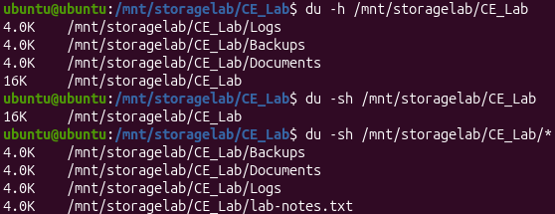
- Display the file-system capacity:

df -h /mnt/storagelab
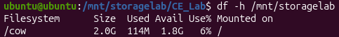
- Create a 100 MB test file to observe the change in storage usage:

fallocate -l 100M /mnt/storagelab/CE_Lab/testfile.bin
- Check the usage again:

du -sh /mnt/storagelab/CE_Lab df -h /mnt/storagelab
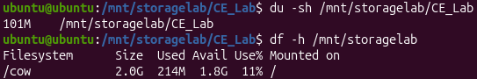
- Remove the large test file when finished:

rm /mnt/storagelab/CE_Lab/testfile.bin
- Verify that the available space has increased or that the file no longer appears in the directory.

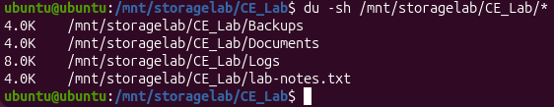

Expected observation: The directory's reported usage should increase after creating the test file. Removing it should generally return that space to the file system.

Guide questions

  - What is the difference between du and df?
- du (disk usage) reports how much space specific files and directories consume. df (disk free) reports capacity, used space, and available space for an entire mounted file system. du answers “what is using the space?”, and df answers “how much space is left?”.
  - Why is monitoring storage usage important for servers?
- It prevents outages caused by full disks, helps find runaway logs or large files, supports capacity planning, and gives early warning before applications, databases, or backups fail.
  - What might happen if a system disk becomes full?
- Applications cannot save data or write logs, databases may corrupt or stop, and updates and installs fail. Temporary files and user logins can also fail, and the system may become unstable or unable to boot properly.

Exercise 6. Manage file permissions

Objective: Demonstrate how Linux protects stored files using access permissions. Instructions
- Create a file on the laboratory partition:

echo "Confidential laboratory data" > /mnt/storagelab/CE_Lab/secure.txt

- Display its current permissions:

ls -l /mnt/storagelab/CE_Lab/secure.txt
- Restrict access so that only the file owner has read and write permission:

chmod 600 /mnt/storagelab/CE_Lab/secure.txt
- Check the permissions again:

ls -l /mnt/storagelab/CE_Lab/secure.txt
- Explain the permission setting 600 in your report.
- It sets the file’s permissions so that only the owner can read and write it. Nobody else has any access.
- Restore ordinary owner read/write access for the file before continuing, if needed: chmod 644 /mnt/storagelab/CE_Lab/secure.txt
Expected observation: The permission display should change after executing chmod. Guide questions
  - Why does an operating system restrict access to files?
- To protect confidentiality, integrity, and system stability in a multi-user environment. Permissions keep users from reading private data, modifying other users’ files, or accidentally or maliciously damaging critical system files.
  - What do read, write, and execute permissions mean?
- Read (r): view a file’s contents, or list a directory’s contents.
- Write (w): modify or delete a file, or add, remove, and rename files within a directory.
- Execute (x): run a file as a program, or enter (traverse) a directory.
  - How can incorrect permissions expose sensitive data?
- Overly open permissions, such as 777 or world-readable 644 on a confidential file, let unauthorized users read, alter, or delete it. Examples include password files, private keys, and personal records. Wrong permissions on executables or scripts can also let attackers modify code that runs with higher privileges.

Exercise 7. Unmount and remount the laboratory disk

Objective: Understand how to safely detach and reconnect a mounted file system. Instructions
- Ensure that you are not working inside the mount directory:

cd ~
- Unmount the partition:

sudo umount /mnt/storagelab
- Verify that the mount point is no longer associated with the partition:

findmnt /mnt/storagelab lsblk -f
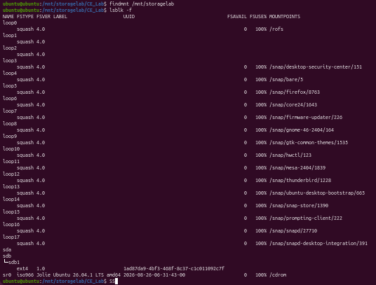
- Attempt to list the laboratory directory:

ls /mnt/storagelab
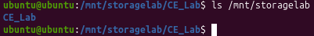
The directory itself may still exist on the Ubuntu system disk, but the files stored on the separate partition will not be accessible through that mount point while the partition is unmounted.

- Mount the partition again:

sudo mount /dev/sdX1 /mnt/storagelab
Replace /dev/sdX1 with the verified partition name.
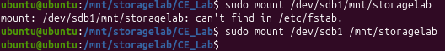
- Confirm that the files remain available:

cat /mnt/storagelab/CE_Lab/lab-notes.txt ls -l /mnt/storagelab/CE_Lab
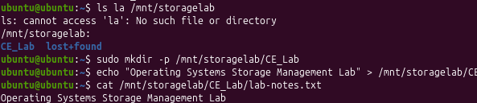
Expected observation: The laboratory files should be available again after the partition is remounted. Guide questions
  - Why should a file system be unmounted before a storage device is detached?
- Unmounting flushes cached data to the disk and closes the file system cleanly. Removing a device while mounted can leave pending writes unsaved, causing corrupted files or file-system errors.
  - What does an error such as “target is busy” mean?
- Something is still using the file system, such as a process with an open file there, or a terminal whose current directory is inside the mount point. You must close or stop those uses (for example cd ~) before unmounting. lsof or fuser can help find the culprit.
  - Does unmounting a file system automatically delete its files?
- No. The files stay intact on the partition. They are just not accessible through the mount point until it is mounted again.

Exercise 8. Storage troubleshooting scenario

Objective: Apply storage-management commands to diagnose a practical problem.

Scenario: A Linux server administrator reports that an application cannot save new files. The application may be using the wrong directory, the file system may not be mounted, or storage capacity may be low.

Instructions

- Check the storage devices:

lsblk -f
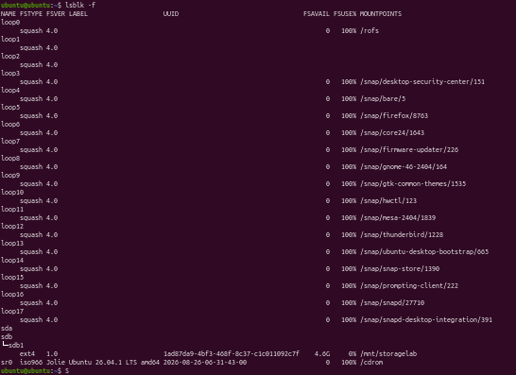

- Check the capacity of mounted file systems:
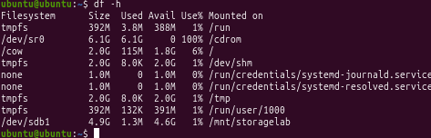
df -h

- Check the laboratory directory's storage usage:

du -sh /mnt/storagelab/CE_Lab

- Verify the mount status:

findmnt /mnt/storagelab
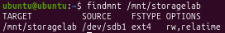
- Based on your output, determine whether the file system is mounted and whether space is available.
- Yes, it is mounted and the space is available
- If the laboratory partition is unmounted, mount it again using the verified partition name: sudo mount /dev/sdX1 /mnt/storagelab
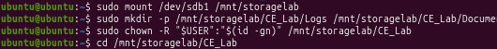
- Create a test file to confirm that writing works:

touch /mnt/storagelab/CE_Lab/storage-test.txt
- Verify that the file exists:

ls -l /mnt/storagelab/CE_Lab/storage-test.txt
- Record the problem you investigated, the commands you used, your observations, and your conclusion.

Guide questions

- Which command provides the fastest overview of mounted storage capacity?
- df -h. It shows each mounted file system’s size, used space, available space, usage percentage, and mount point in readable units.
- How can a missing mount cause an application to save files in the wrong location?
- If the partition is not mounted, the mount-point directory (such as /mnt/storagelab) still exists on the system disk. The application writes into that plain directory, so the data goes to the system disk instead of the intended storage. This can fill the system disk, and the files appear to disappear once the real partition is mounted over that directory.
- What additional checks would you perform if the disk has free space but writing still fails?

- Inodes: df -i (the disk can run out of inodes even with free space).
- Permissions and ownership: ls -l, and whether the user can write to the directory.
- Read-only mount: check findmnt or mount for ro, which can happen after file-system errors.
- File-system errors: check dmesg or logs, and run fsck on the unmounted partition.
- Disk quotas or other limits.
- Hardware or virtual-disk problems, such as the host running out of space for a dynamically allocated VDI.

Optional extension: Persistent mounting using UUID

This extension demonstrates how to configure Ubuntu to mount the laboratory partition automatically after reboot.

Perform this only after the main exercises are complete and your instructor approves. An incorrect /etc/fstab entry can cause boot or mounting problems.

  - Retrieve the partition's UUID:

sudo blkid
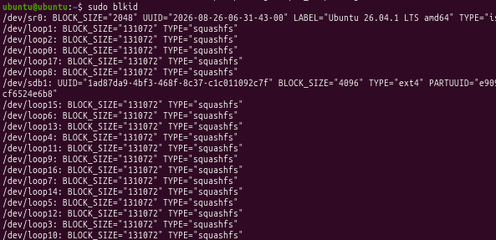
  - Identify the UUID belonging to the laboratory ext4 partition.
  - Back up the mount configuration: sudo cp /etc/fstab /etc/fstab.backup
  - Open the configuration file:

sudo nano /etc/fstab
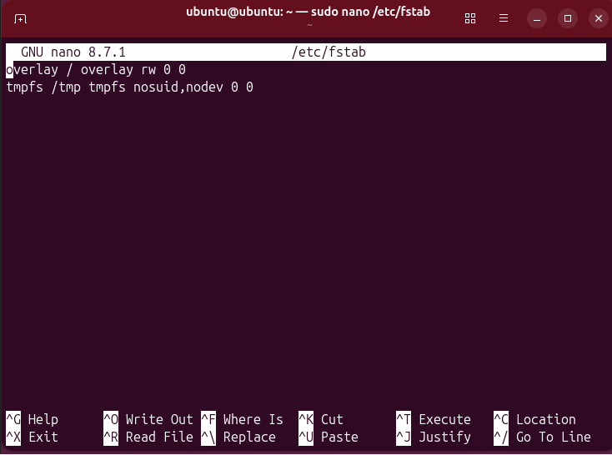
  - Add a line at the end, replacing YOUR-UUID-HERE with the actual UUID:

UUID=YOUR-UUID-HERE /mnt/storagelab ext4 defaults,nofail 0 2

- Save and exit the editor.
- Test the configuration before rebooting:

sudo findmnt --verify
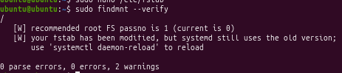sudo mount -a
findmnt /mnt/storagelab
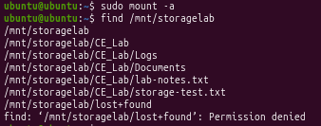
- If an error appears, correct or remove the new entry before restarting the VM. Use the backup if needed: sudo cp /etc/fstab.backup /etc/fstab
Guide question: Why is using a UUID generally more reliable than referring to a disk by a name such as /dev/sdb1?
- Using a UUID (Universally Unique Identifier) is generally more reliable than referring to a disk by a device name like /dev/sdb1 because device names are dynamically assigned by the kernel based on detection order during boot. If you add, remove, or change hardware controller ports, a drive that was previously /dev/sdb1 can easily shift to /devsdc1 or another name, which would cause mounting failures or system boot issues.

Laboratory worksheet and submission

Students should submit a laboratory report containing the following information.

Submission checklist

0 of 8


- Storage inventory

Record the disk names, sizes, partitions, file systems, and mount points observed in Exercise 1.

- Partitioning and formatting

Include the commands used and screenshots or terminal output verifying the new partition and ext4 file system.

- Mounting and file management

Show the mount point, created directories, test files, and successful file read/write operations.

- Storage analysis

Compare disk usage before and after creating the 100 MB file. Include the output of df -h and du -sh.

- Permissions

Show the file permissions before and after chmod 600 and explain the difference.

- Unmount/remount test

Explain what changed when the file system was unmounted and remounted.

- Troubleshooting analysis

Describe the issue investigated, diagnostic commands, findings, and recommended solution.

- Conclusion

Explain how storage management contributes to performance, reliability, and data protection.

Laboratory performance rubric

Total: 100 points

Criteria | Points
Correct identification of storage devices and partitions | 10
Successful partitioning and file-system formatting | 20
Correct mounting and unmounting procedures | 15
File and directory management | 10
Storage-usage analysis and interpretation | 15
File-permission configuration | 10
Troubleshooting and problem analysis | 10
Laboratory report, screenshots, and conclusion | 10
Total | 100

Post-laboratory analysis questions

Answer these questions in your own words. 10pts each

  - Differentiate a disk, a partition, a file system, and a mount point.
- A disk is the whole storage device. A partition is a section of the disk. A file system organizes how files are saved inside the partition. A mount point is the folder where the partition is connected so we can use it.
  - What are the advantages of using a separate virtual disk for laboratory activities?
- It keeps our practice away from the main Ubuntu system, so mistakes won’t damage important files. It’s also easy to delete and redo.
  - How do lsblk, df, and du complement one another when troubleshooting storage?
- lsblk shows the disks and whether they are mounted. df shows how much space is left. du shows which folders use the most space. Together, they help find the problem.
  - Why might a file system have free capacity but still fail to accept a write operation?
- The user may not have permission to write, the disk may be read-only, or the partition may not be mounted properly.
  - What is the purpose of file permissions in a multi-user operating system?
- Permissions control who can read, change, or run a file. This keeps files private and safe from other users.
  - What could happen if a system administrator formats the wrong disk?
- All the data on that disk could be erased. If it’s the system disk, the computer may not start anymore.
  - Why should engineers verify mount status before allowing an application to write data?
- If the disk isn’t mounted, the app will save files on the main system disk instead. This can fill it up, and the data will look missing later.
  - How does persistent mounting help automate system administration?
- The disk connects automatically every time the computer starts, so the administrator doesn’t have to mount it by hand each time.
  - What precautions should be taken before modifying /etc/fstab?
- Make a backup copy of the file, double-check the UUID and spelling, and test the changes before restarting.
  - Give one real-world example in which effective storage management is important in a Computer Engineering system, such as an embedded device, server, or data-acquisition system.
- A weather station that records data all day needs enough free space and a properly connected disk. Otherwise, it stops saving and readings are lost.

